Tafadzwa Kashiri

ST10057559

CLDV6211 Part 2

Results

Query 5. Write a query that will return all the rentals placed between the following dates “2021-08- 01” AND “2021-10-30”.

(Stack Overflow, 2021)

Query 6. Write a query that selects all the rentals placed by Bud Barnes.

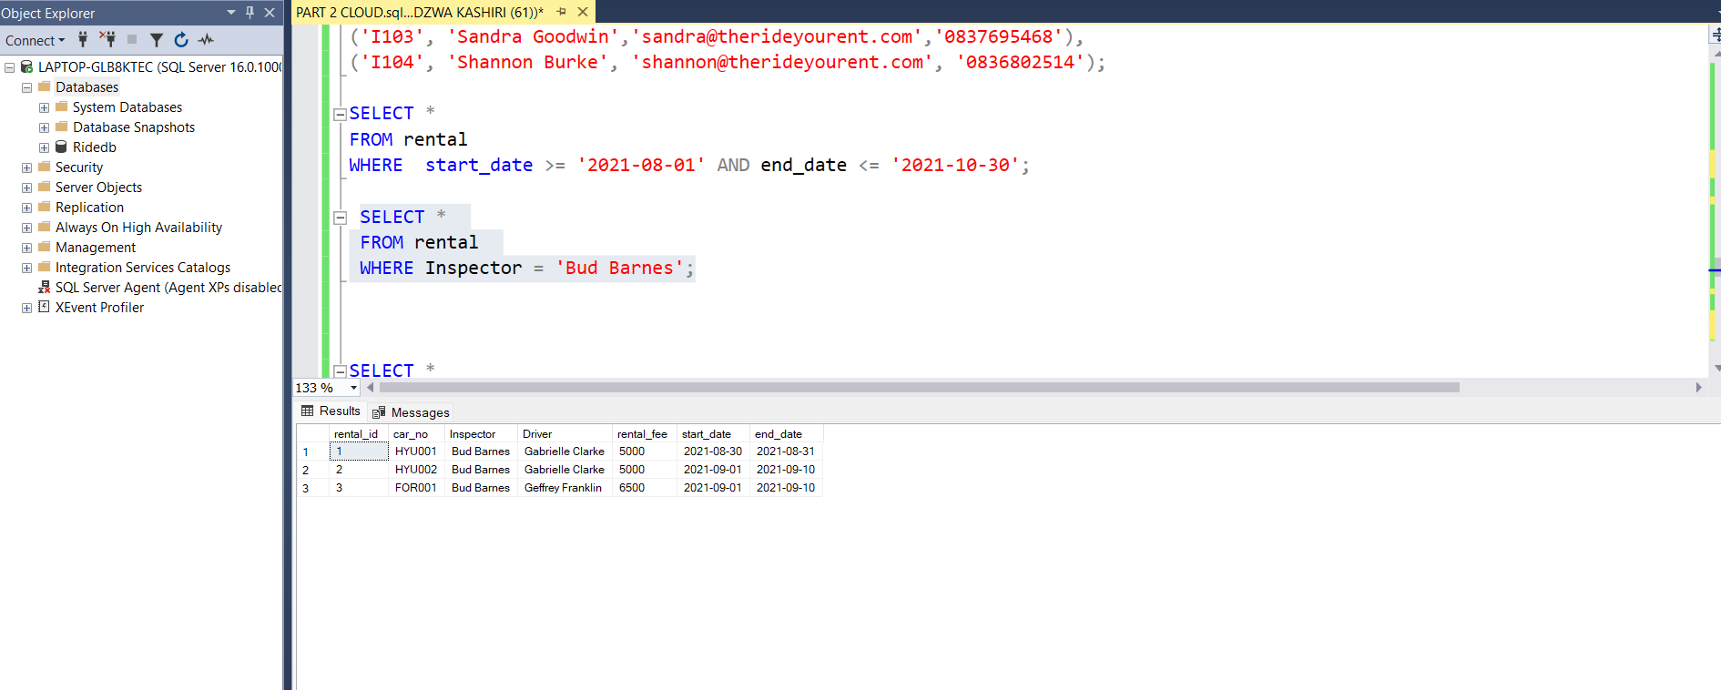

(Stack Overflow, 2021)

Query 7. Write a query that displays all the returns for the car make Toyota.

Query 8. Write a query that counts the number of rentals that were placed for the car make Hyundai

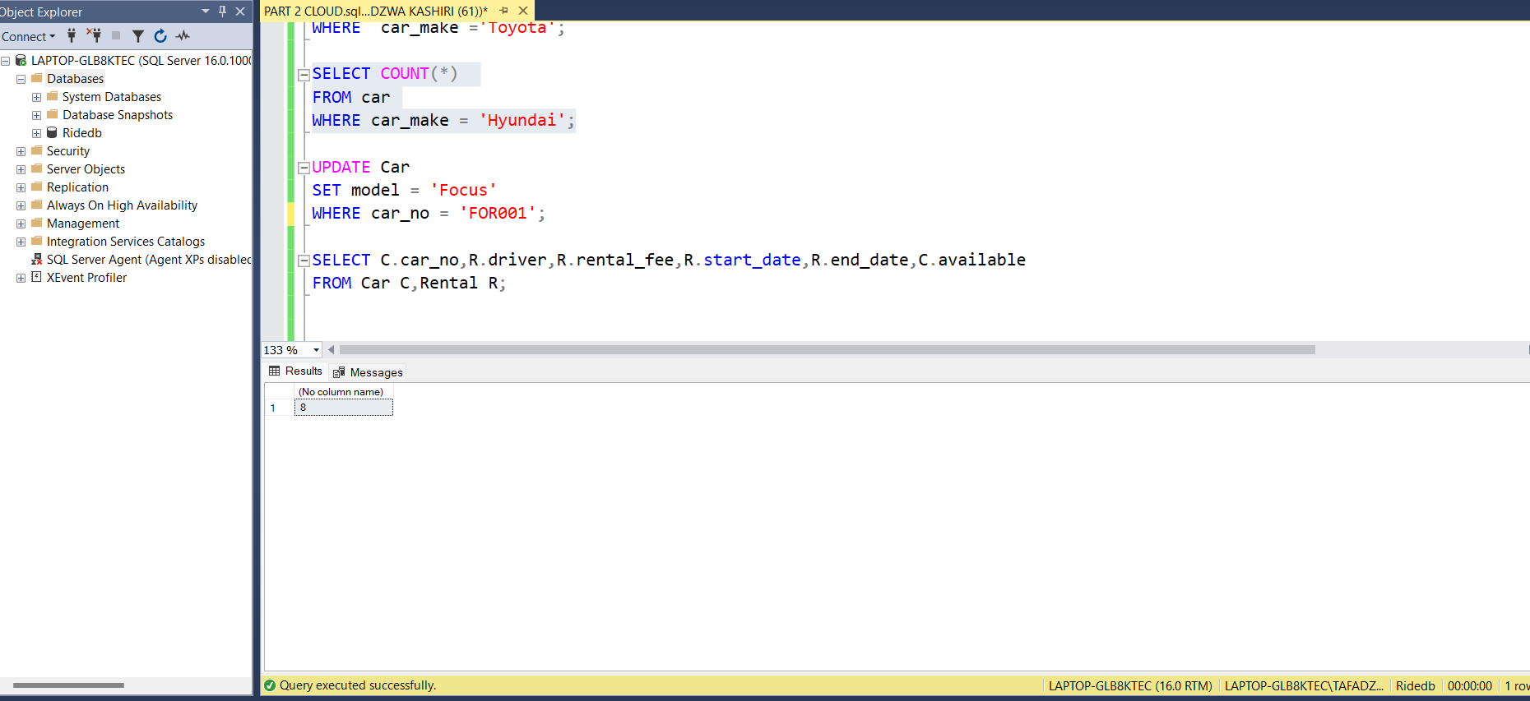

(W3Schools, 2022)

Query 9. Write a query to update the Model of the car with the CarNo FOR001 from “Fiesta” to “Focus”.

(W3Schools, n.d.)

Query 10. Write a query that will display the CarNo, Driver Name, Rental Fee, Start Date, End Date and Availability of all available rentals.

(Chartio, n.d.)

(W3Schools, n.d.)

Query 12. Write a query that will determine the cars which will need service soon. If a car’s kilometres travelled is 9000 kilometres away from the service kilometres that would indicate that the car would need to get a service soon.

(Stack Overflow, 2018)

Query 13. Write a query that will calculate the late fee for a return (a R500 a day fine is placed on rentals returned passed the elapsed return date. The query should use the return date and the current/Today’s date to calculate the elapsed number of days and multiply those days by the R500 fine to get the total fine)

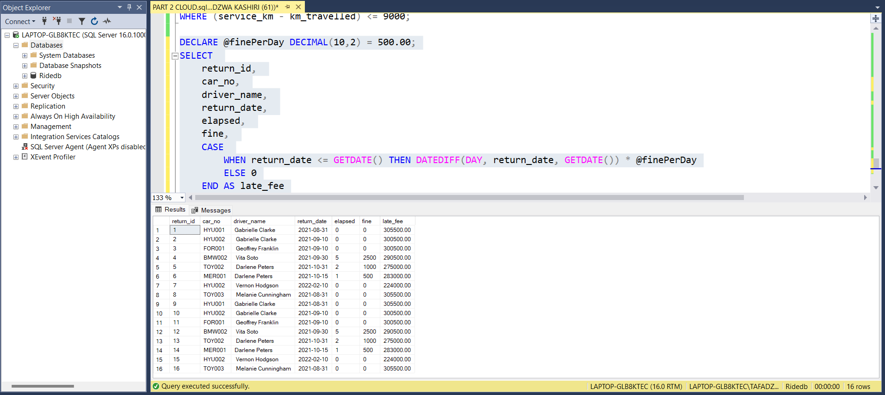

(Stack Overflow, 2011)

The connection to my MS Azure SQL Server (shown in my local SSMS) with at least one table result called back as a query.

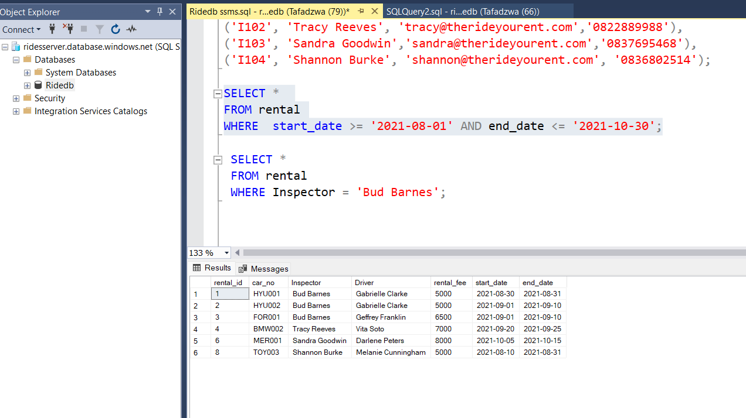

The data shows up in the query editor on Microsoft Azure

# Bibliography

Chartio, n.d. *SQL Server List Tables.* [Online]   
Available at: https://chartio.com/resources/tutorials/sql-server-list-tables-how-to-show-all-tables/  
[Accessed 4 May 2023].

Stack Overflow, 2011. *Calculating "first overdue" date from a payment schedule.* [Online]   
Available at: https://stackoverflow.com/questions/34182344/calculating-first-overdue-date-from-a-payment-schedule  
[Accessed 4 May 2023].

Stack Overflow, 2018. *sql query for counting distance travelled.* [Online]   
Available at: https://stackoverflow.com/questions/15446246/sql-query-for-counting-distance-travelled  
[Accessed 4 May 2023].

Stack Overflow, 2019. *How to auto-complete all columns in "select * from table".* [Online]   
Available at: https://stackoverflow.com/questions/26170324/how-to-auto-complete-all-columns-in-select-from-table-in-sql-server-manageme  
[Accessed 4 May 2023].

Stack Overflow, 2021. *Re-Calculate dates and amounts based on the calendar ....* [Online]   
Available at: https://stackoverflow.com/questions/68774563/re-calculate-dates-and-amounts-based-on-the-calendar-quarter  
[Accessed 4 May 2023].

W3Schools, 2022. *COUNT(Transact-SQL)-SQL server.* [Online]   
Available at: https://www.w3schools.com/sql/func_sqlserver_count.asp  
[Accessed 4 May 2023].

W3Schools, n.d. *SQL SELECT DISTINCT statement.* [Online]   
Available at: https://www.w3schools.com/sql/sql_distinct.asp  
[Accessed 5 May 2023].

W3Schools, n.d. *SQL UPDATE statement.* [Online]   
Available at: https://www.w3schools.com/sql/sql_update.asp  
[Accessed 5 May 2023].